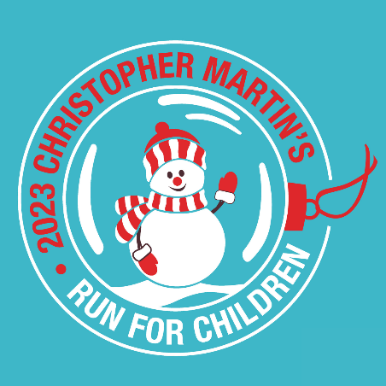

Christopher Martin’s Christmas Run for Children
December 3, 2023
 | Until SOLD OUT
5K | $35
5K + Unwrapped Toy | $25
Shirts Sold Separately! | $20

Checks Payable To: Christopher Martin’s Christmas Run for Children
2 Buena Vista Road
Branford, CT 06405

Circle shirt size: XS S M L XL 2XL

◻ I am paying a reduced rate of $25 and will donate a toy on race weekend.

Last Name First Name

Address

City State Zip

Age_______ Male______ Female_______ Date of Birth: / /

Email

WAIVER: I know that participating in a road race is a potentially hazardous activity. I will not enter and participate unless I am medically able and properly trained. I assume all risks from participating in this event and its related activities, including but not limited to, falls, contact with other participants, effects of the weather (including cold temperatures, ice and winds), traffic, and other conditions of the road, all such risks being known and appreciated by me. Having read this waiver and release and knowing these facts and in consideration of your accepting my entry fee and participation, I, for myself and anyone entitled to act on my behalf waive and release City of New Haven, New Haven Police Department, race officials, Christopher Martins Restaurant, John Bysiewicz, JB Sports LLC, volunteers and all sponsors and their respective affiliates, subsidiaries, principals, directors, agents, officers, employees of contractors of from all claims or liabilities of any kind arising out of my participation in this event or its related activities which I or my successors, assigns or heirs may ever have nor or in the future against any of them. I grant permission to all of the foregoing to use any photographs, motion pictures, recordings, or any other record of this event for any lawful purpose.

Signature (Parent must sign if competitor is under 18.) Date

